**MARATHWADA MITRA MANDAL’S COLLEGE**

302/A, Deccan Gymkhana, PUNE-411004

**A**

**PROJECT REPORT ON**

***Dance Studio Website____________***

Submitted in partial fulfilment of the requirements

For the award of the Degree of

**Bachelor of Science (Computer Science)**

**Under guidance of**

**Asst. Prof. Shaheen Mulani**

Submitted by:

***Krishi Taank***

***Soniya Singh***

Savitribai Phule Pune University

(2023-2024)



**MARATHWADA MITRA MANDAL’S COLLEGE**

BACHELOR OF SCIENCE (COMPUTER SCIENCE)

302/A, Deccan Gymkhana, PUNE-411004

**CERTIFICATE**

**This is to certify that**

***Krishi Taank***

***Soniya Singh***

**Have completed the project entitled**

***‘Dance Studio Website’***

**in a partial fulfilment for the award of**

**Bachelor of Science (Computer Science)**

### Savitribai Phule Pune University

**Academic Year 2023-2024**

**Internal Examiner External Examiner**

**Prof. Shaheen Mulani Prof.Nidhi Satavlekar Dr. Devidas Golhar**

**Guide HOD Principal**

|  |  |  |
| --- | --- | --- |
|  | Index |  |
| **Sr No.** | **Topic Name** | **Page No** |
| 1. | **Introduction**   * Introduction of System * Scope of System * Proposed System |  |
| 2. | **System Analysis**   * Fact Finding technique * Feasibility Study * Hardware Requirements * Software Requirements |  |
| 3. | **System Design** |  |
| * E-R diagram * Context level diagram * Data Flow diagram * File Design * Data Dictionary |
| 4. | **Form Design** |  |
| 5. | **Reports** |  |
| 6. | **Limitations** |  |
| 7. | **Advantages and Disadvantages** |  |
| 8. | **Future Enhancement** |  |
| 9. | **Bibliography** |  |



Dance Studio84

## 1. Introduction

## 

Studio84 is a website, which serves passionate dance lovers to find their flexibility timings to follow their passion and convert it into the profession. Studio84 is a platform where we believe in the power of dance to transform lives and build community. Our mission is to provide a nurturing and inspiring environment for dancers of all ages and skills levels to explore their passion for dance.

At our studio, we offer a wide range of dance classes, form kathak and garba to Bollywood and hip hop, taught by experienced and dedicated instructors. Whether you’re a beginner just starting out or an experienced dancer looking to take your skills to the next level, we have something for everyone.

Our state-of-art facilities are equipped with everything you need to dance your best, including sprung floors, floor length mirrors, and high-quality sound systems. We also offer world-class dance studio management software to help you manage your classes and schedule with ease.

### Scope of System

The scope of dance studio website is that it should provide an optimal viewing experience on various devices, ensuring responsive design. It should offer an integrated scheduling system for class enrolment, displaying available classes, times, and instructors with real-time booking, payment, and confirmation options. High-quality video integration is essential for showcasing the studio's energy and expertise. In terms of content, a dance studio website should include sections for class schedules, instructor bios, pricing information, enrolment forms, and an about page highlighting the studio's history and mission. Multimedia elements such as photo galleries or videos can showcase classes, events, and performances.

### Proposed System

Studio84 is a platform for learners to get a dance training from an experienced dancers who have been the choreographers since 6-7 years in Bollywood industry. We have a contact facility with no compulsion of registration and can contact us from mail, Instagram a can directly call us.

Studio84 has more than one dance forms to provide, and our speciality is Garba which is a traditional dance form of Gujarat.

Studio84 also provides a state level and national level competitions with the online certificates, flexible timings and rate depending on their choice of their dance form. Youngsters now a days wants their passion to be their career which they think is difficult. Here is the solution, we can make it easy and will help them to pursue their dream.

## 2. System Analysis

### 2.1 Fact Feasibility technique

1. **Assessing need and demand:** Conducting of market research to understand the demand for a dance studio in the local area. This could involve surveying potential customers, researching competing studios, and analyzing demographic trends.
2. **Designing the space:** Consider the layout and design of the studio to ensure it is functional, safe, and appealing to customers. This may involve consulting with dance instructors, architects, and interior designers.
3. **Selecting equipment:** Choose equipment that is appropriate for the types of dances offered at the studio. This may include ballet barres, mirrors, sound systems, and flooring.
4. **Hiring instructors**: Recruit qualified and experienced dance instructors who are passionate about teaching and have strong communication skills.

### 2.2 Feasibility Study

1. **Identifying website goals:**Defining the goals of the website, such as increasing enrollment, promoting classes, and providing information about the studio.
2. **Market Analysis:** Identifying the target market, such as professional dancers, dance enthusiasts, schools, or community groups. Analyze the demand and supply for dance studio services in the chosen location
3. **Competitive Analysis**: Identifying competitors in the market and analyze their strengths and weaknesses.
4. **Staffing:** Determine the number of workers needed and the qualifications required for each position.
5. **Cost Analysis:** Estimating the cost of providing the service, including rent, utilities, equipment, salaries, and marketing. Determining the service fee that will cover the costs and generate a profit.

#### 2.3 Hardware Requirements

* A computer with at least 4GB RAM and 2GHz processor
* At least 500MB of free disk space for the project
* Internet connectivity for accessing the website

#### 2.4 Software Requirements

* HTML
* CSS
* JavaScript
* Visual Studio Code
* PostgreSQL

Xampp

* Browser- Chrome
* PHP

## 3. System Design

#### 3.1 E-R Diagram

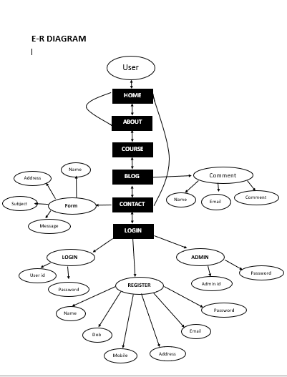

#### 3.2 Context Level Diagram

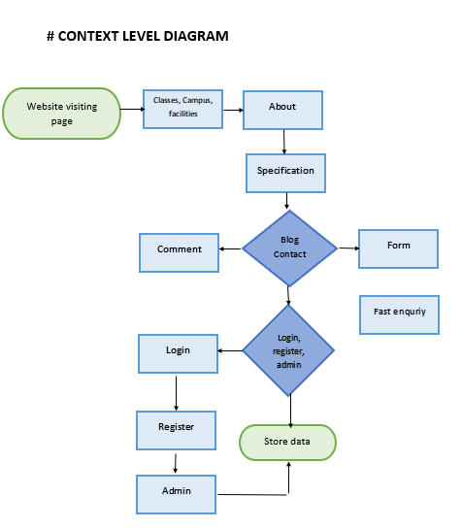

#### 3.3 Data Flow Diagram

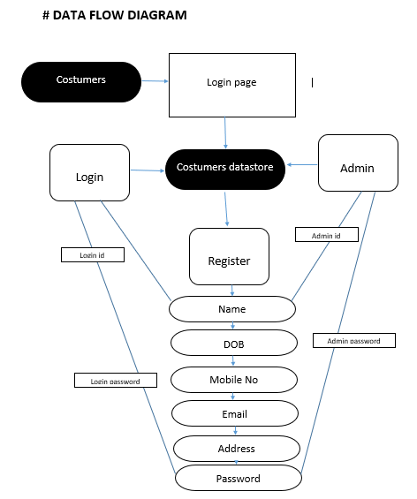

#### 3.4 File Design

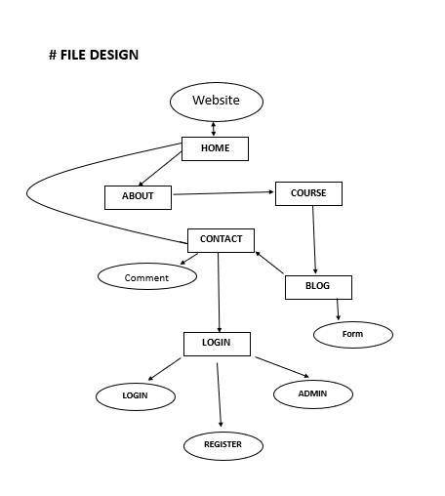

#### 3.5 Data Dictionary

Database used for Studio84 website is PostgreSQL.

Table: Admin

* Column: user_id(Primary key)
* Column: password (varchar (20))

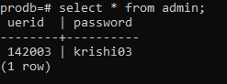

Table: Register

* Column: sname(varchar(20))
* Column: dob (varchar (20))
* Column: phno (int)
* Column: email (varchar (30))
* Column: addr (varchar (30))
* Column: password (varchar (20))

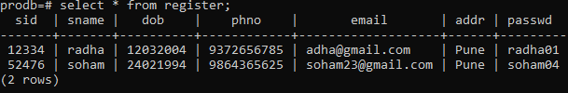

## 4. Form Design

**Home page**

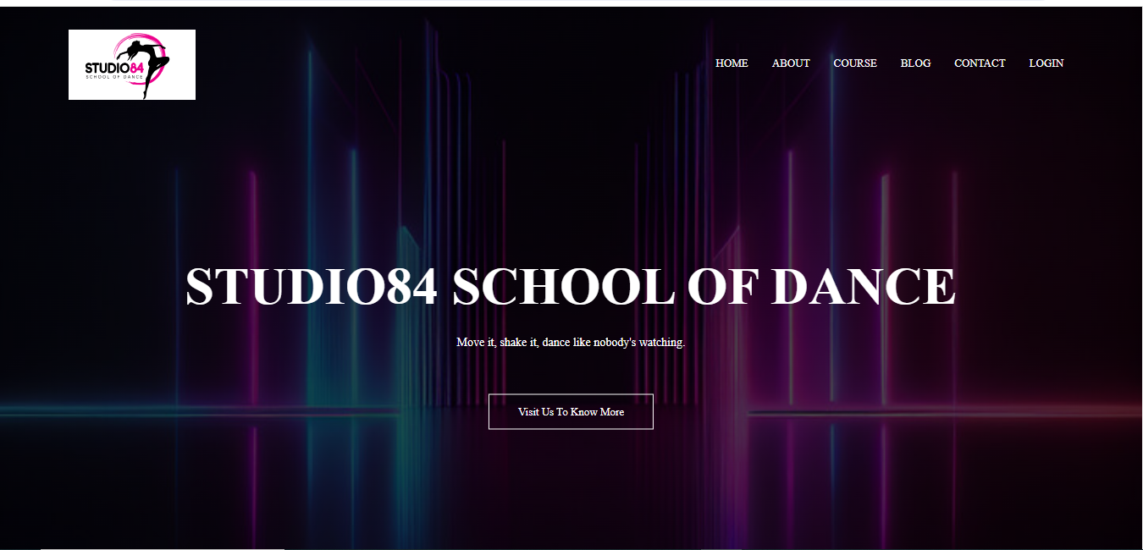

**About us**

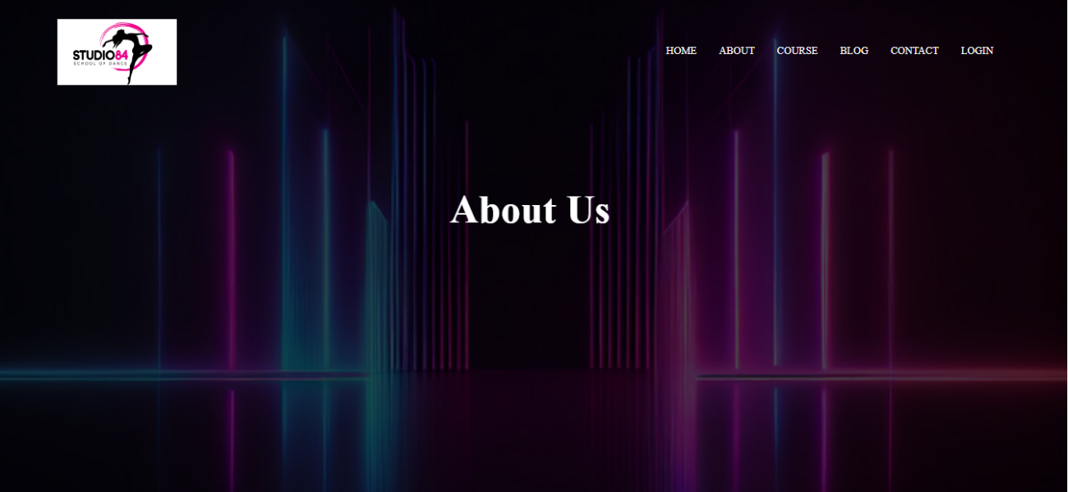

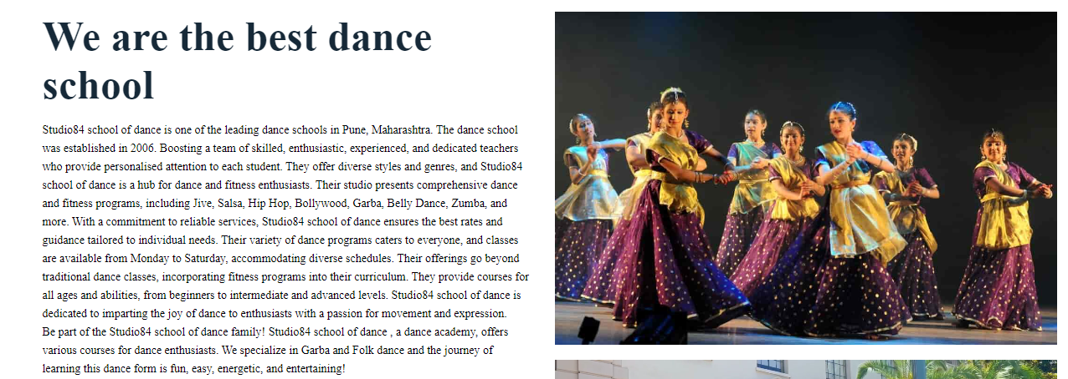

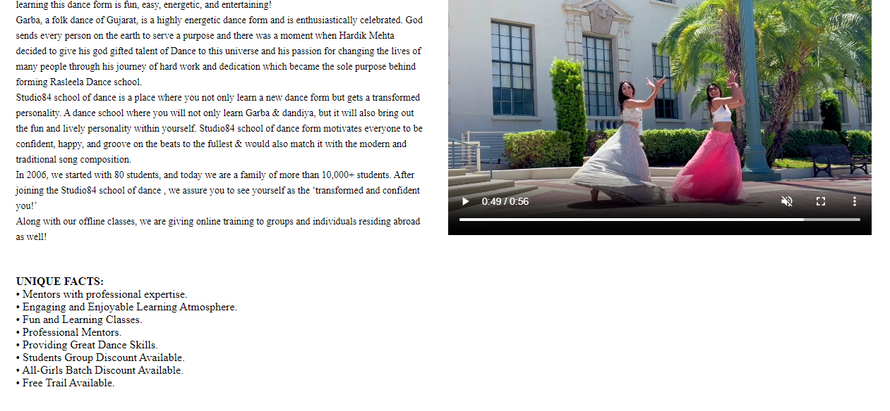

**Courses**



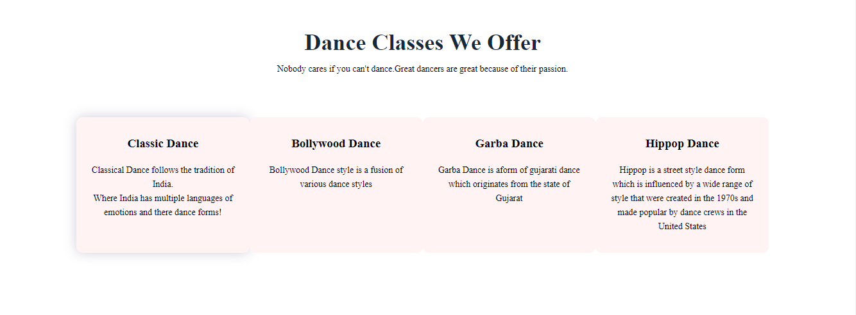

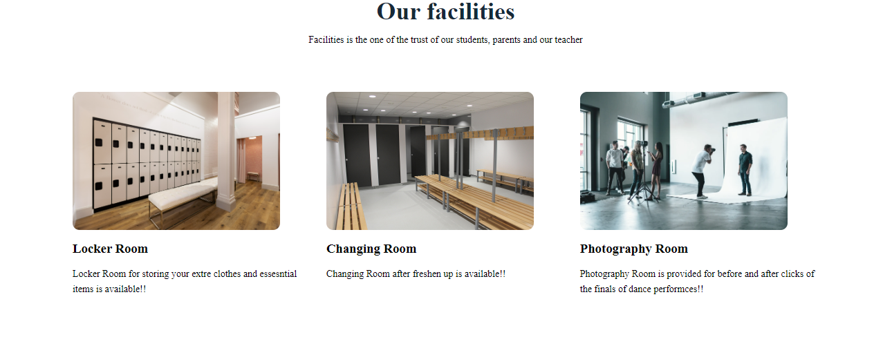

**Blog**



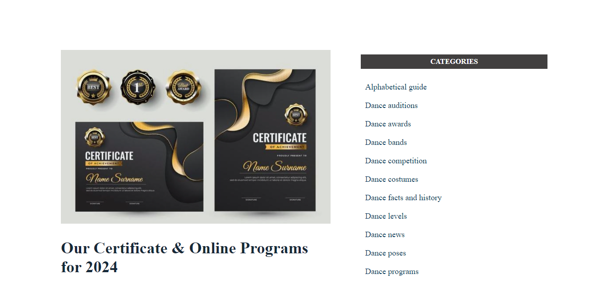

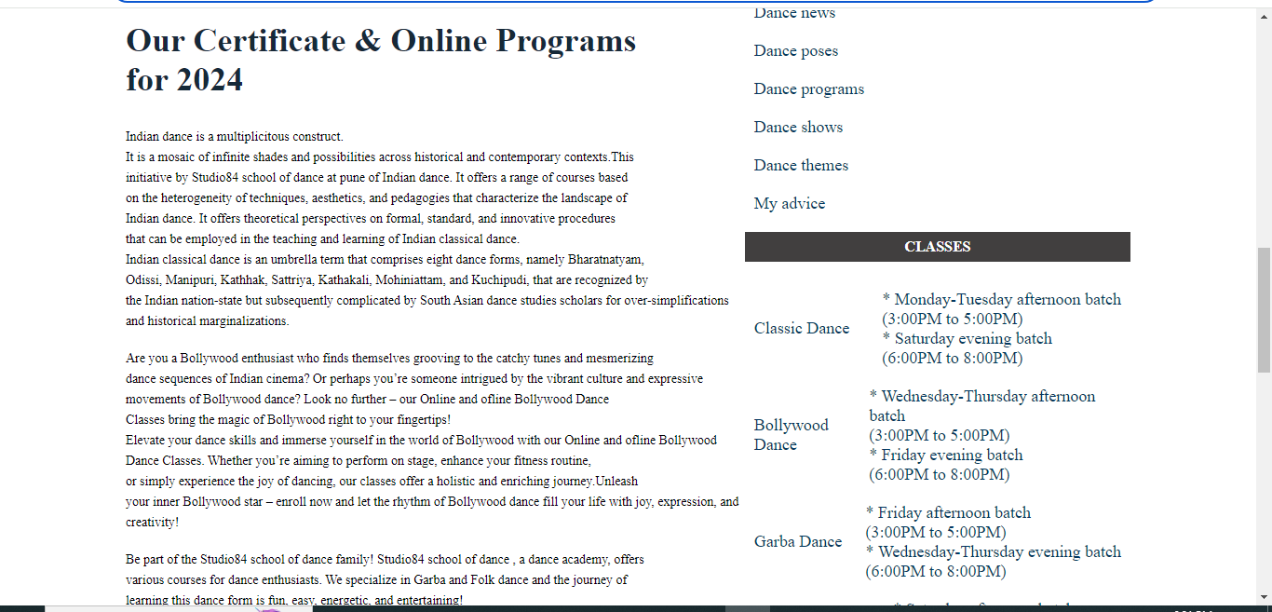

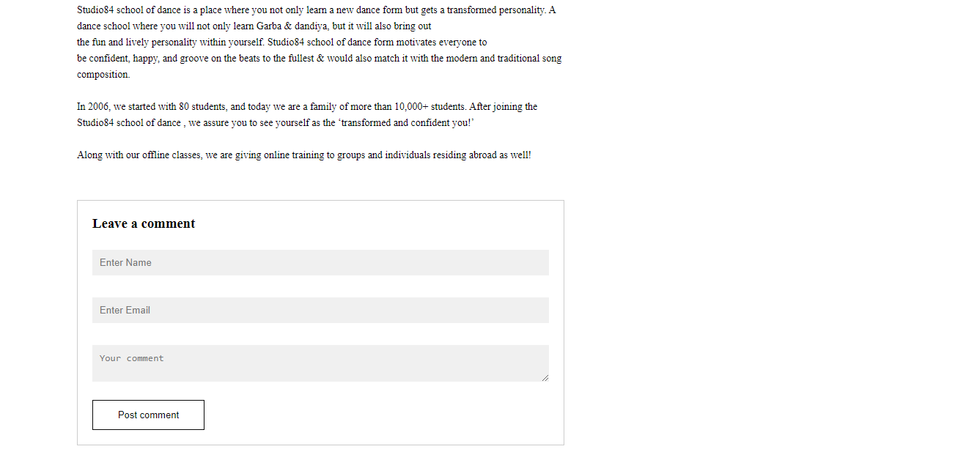

**Contact**



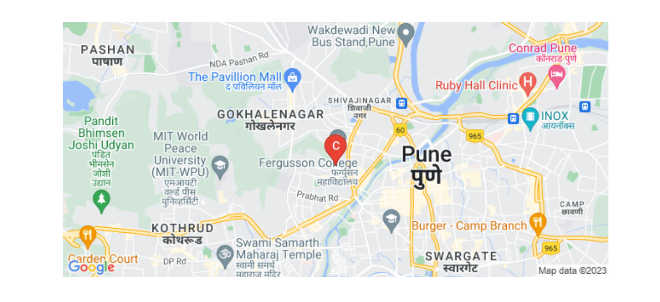

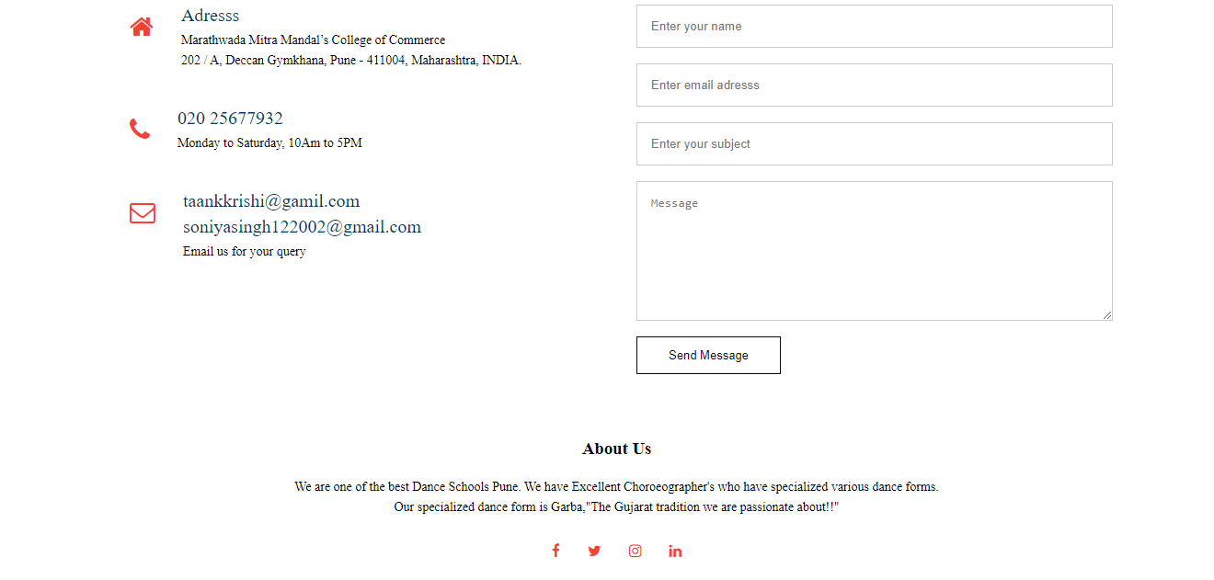

**Login**

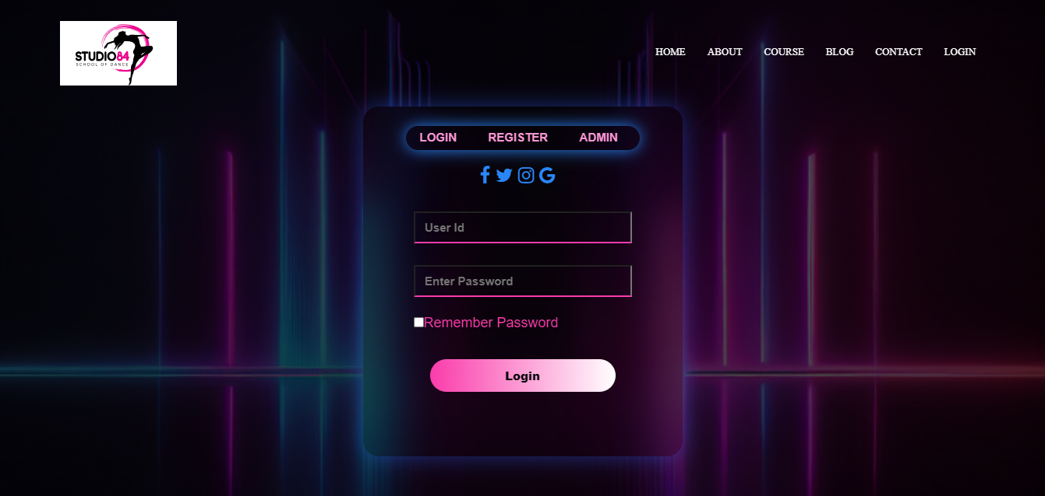

**Register**

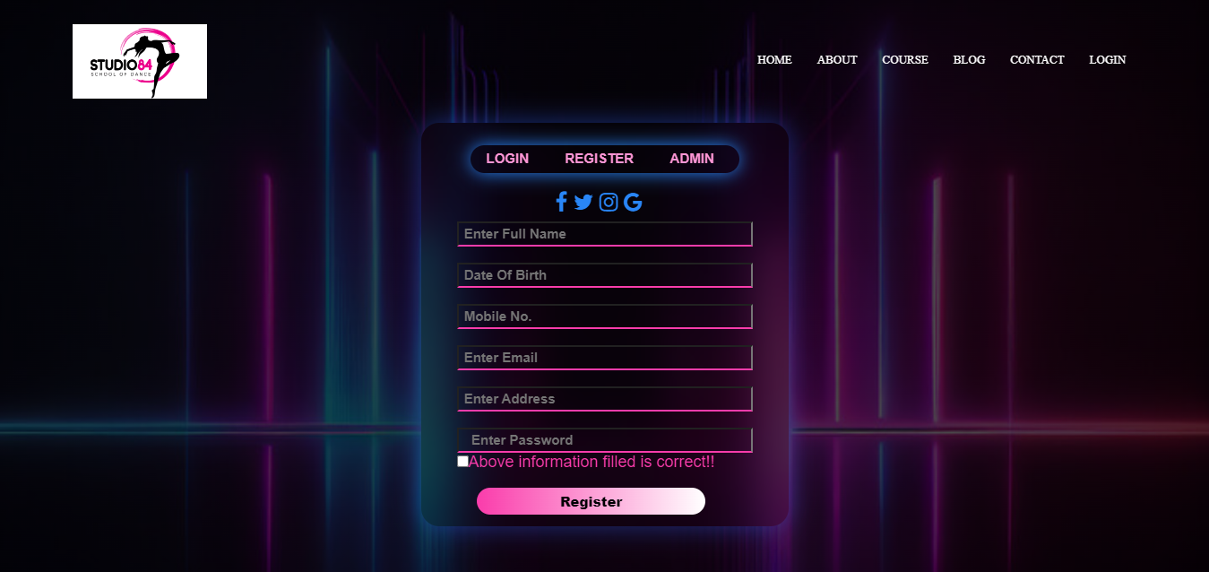

**Admin Login**

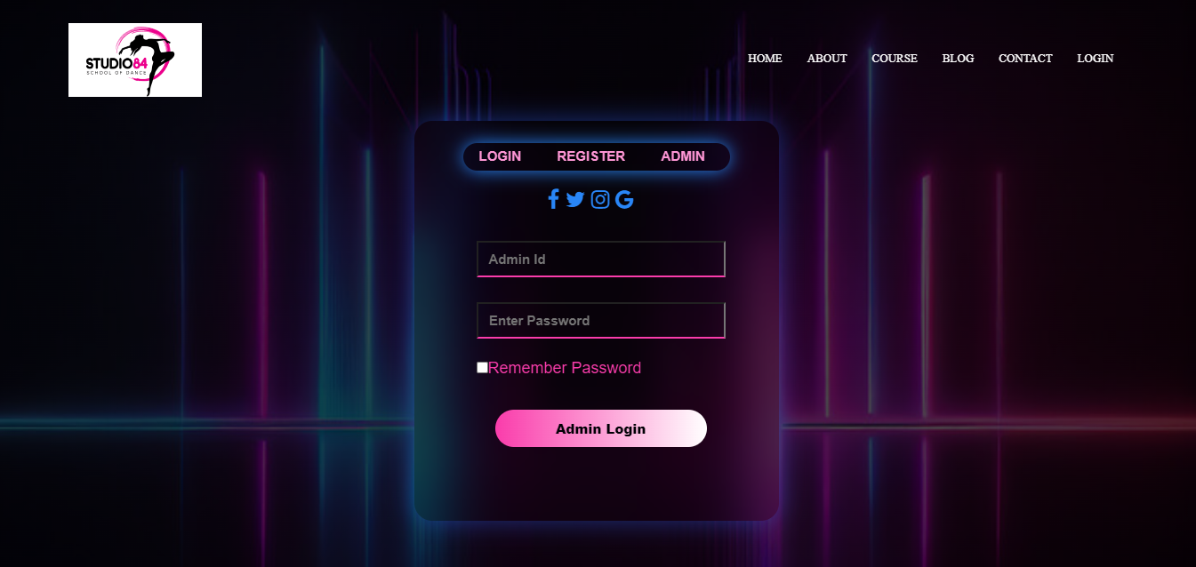

## Reports

A dance studio website can serve as a powerful marketing tool for the studio, providing information about classes, schedules, and instructors. The website can also offer online registration and a direct contact, making it easier for students to register for classes.

The website can be built using various technologies such as HTML, CSS, JAVASCRIPT, and PHP. A database like POSTGRESQL can be used to store and manage information about students, classes, their schedule

Additional features the studio includes such as a photography session before and after the competitions we offer, we have 3 large halls for practices and a great sound system, there is no age restriction in our studio to follow their dance passion.

The website can also serve as a management tool for the studio, allowing the studio to communicate with students through email or text messages.

Overall, a dance studio website can help to increase visibility, streamline operations, and enhance the experience for students.

## Limitations

Some limitations of a dance studio include the limited availability of classes and instructors, which can make it difficult for students to find a class that fits their schedule or skill level.

Additionally, the cost of classes and the need for specialized equipment or studio spaces can be a barrier for some students.

The lack of flexibility in terms of the types of dances that are offered. A dance studio may specialize in a specific style of dance, such as garba or hip-hop, which may not appeal to all students. This can limit the diversity of the student body and the types of dances that students are exposed to.

Studio84 may also have limitations in terms of the accessibility of classes. Students with disabilities or mobility issues may have difficulty participating in certain classes, and the lack of accommodations can make it difficult for these students to fully participate and benefit from the classes. It is important for dance studios to address these limitations by offering a variety of classes and schedules, providing financial assistance and scholarships, and ensuring that classes are accessible to all students.

## Advantages and Disadvantages

**Advantages:**

* Access to specialized equipment,
* Trained instructors
* A dedicated space for practicing and performing.
* Provide opportunities for dancers to connect with others who share their passion.
* Takes their passion to pursue their dream

**Disadvantages:**

* Limited Availability of classes
* Difficult to find the class that its their schedule of a particular dance form.
* Cost.

## Future enhancement:

Future enhancement of Studio84 dance studio includes:

* Implementing a user-friendly interface for scheduling and managing classes and events
* Integrating a payment system for easy and secure transactions
* Adding a feature for virtual classes or remote learning
* Developing a mobile app version of the website for on-the-go access
* Integrating with social media platforms for easy sharing and promotion of classes and events

## Bibliography

* [**Dancing Revelations: Alvin Ailey's Embodiment of African American Culture** by Thomas F. DeFrantz](https://login.avoserv2.library.fordham.edu/login?url=http://quod.lib.umich.edu/cgi/t/text/text-idx?c=acls;idno=heb05770)
* [**Embodying Mexico** by Ruth Hellier-Tinoco](https://catalog.library.fordham.edu/uhtbin/cgisirsi/x/0/0/57/5/0?searchdata1=1686195%7BCKEY%7D&searchfield1=GENERAL%5ESUBJECT%5EGENERAL%5E%5E&user_id=WEBSERVER)
* [**The Life and Ballets of Lev Ivanov** by Roland John Wiley](https://login.avoserv2.library.fordham.edu/login?url=http://quod.lib.umich.edu/cgi/t/text/text-idx?c=acls;idno=heb05954)
* [**Music and Dance Traditions of Ghana: History, Performance, and Teaching** by Paschal Yao Younge](https://catalog.library.fordham.edu/uhtbin/cgisirsi/x/0/0/57/5/0?searchdata1=1652675%7BCKEY%7D&searchfield1=GENERAL%5ESUBJECT%5EGENERAL%5E%5E&user_id=WEBSERVER)
* [**Film Choreographers and Dance Directors: An Illustrated Biographical Encyclopedia, With a History and Filmographies, 1893 Through 1995** by Larry Billman](https://catalog.library.fordham.edu/uhtbin/cgisirsi/x/0/0/57/5/0?searchdata1=592977%7BCKEY%7D&searchfield1=GENERAL%5ESUBJECT%5EGENERAL%5E%5E&user_id=WEBSERVER)
* [**Classical Ballet Terms** by Richard Glasstone](https://catalog.library.fordham.edu/uhtbin/cgisirsi/x/0/0/57/5/0?searchdata1=800487%7BCKEY%7D&searchfield1=GENERAL%5ESUBJECT%5EGENERAL%5E%5E&user_id=WEBSERVER) ,Call Number: REF GV1585. G53 2001 (RH)

Alton, Hampshire: Dance Books, 2001.